Control of HVAC System

Most buildings are equipped with various scales and types of an HVAC system. The purpose of these control systems is to maintain a favorable temperature, humidity, and/or air quality of building interiors. Failing to do this right has consequences in productivity, health, and can damage production equipment in industrial buildings.
This project will investigate methods of achieving favorable air conditions inside an experimental setup. The project will use Matlab/Simulink to send and receive sensor and fan/valve signals from a small-scale process setup located in the electronics lab of Aalborg University Esbjerg. The test setup is already constructed and ready for control implementation via Simulink desktop real time. The system is characterized by having many inputs (voltage to ventilator fan, lights, heating, valve) and many outputs (several temperature sensors, moisture, light level).
The project must include:
- Select a control loop (what will be maintained by manipulating what?).
- Obtain a model of the system using experiment data (step response).
- Implement and test control.
The project can include:
- Investigate sensors and actuators, their signals, conversions, advantages, limitations.
- Investigate energy consumption.
- Review the performance of the designed controllers.
- Review of tuning methods.
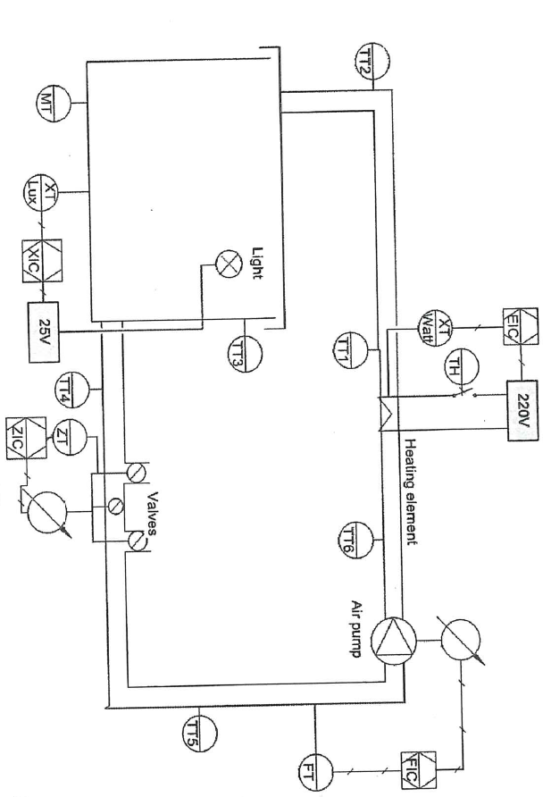
This project will be supervised by Mads V. Bram: mvb@energy.aau.dk

